The Power Grid

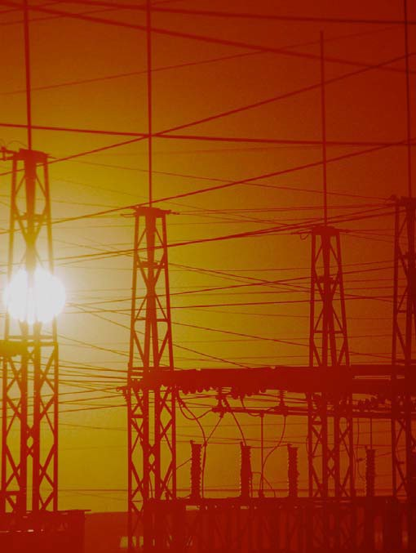

TCIP Educational Development
TCIPG: Trustworthy Cyber Infrastructure for the Power Grid

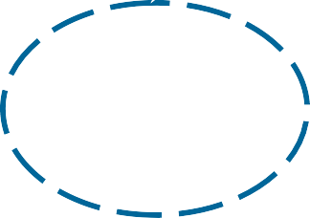The Power Grid

Comments for Teachers

Lesson 1

The applet at http://tcipg.mste.illinois.edu/applet/pg provides a simulation of a large scale power system network.

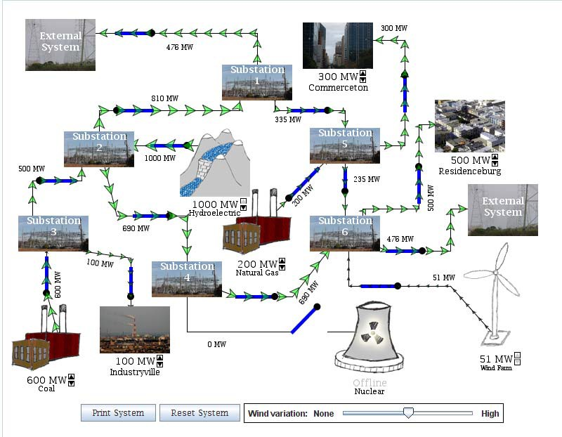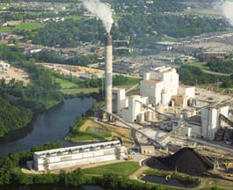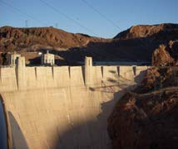Encourage students to explore the

- The green arrows show the direction the power is moving. The current is flowing out of the
applet. Then use the lessons on the student pages to focus their explorations.
Hydroelectric generators

generators, through the substations and into the communities.
Bigger arrows indicate more power.
There are more than 6000 utility scale generators in the U. S. They are powered by burning coal, oil or natural gas, or by nuclear fission, falling
water or wind.
use differences in water elevations to drive turbines. One famous example is the Hoover Dam.

- You can open or close the blue switches by clicking them with the mouse.
- There are five generators represented in this simulation.
The coal, hydropower and natural gas generators have adjustable outputs. The others do not.
Natural gas generators tend to be expensive to operate, but they are capable of changing their output quickly.
Click on the up and
down arrows to the right of MW output labels to change the

Wind turbines are clus- tered together to make wind

production. All of the generators have blue connection switches.
Coal generators are the cheapest fossil based generators.
They can change
their output a little less quickly than the
natural gas generators.

Nuclear generators are
farms capable of produ
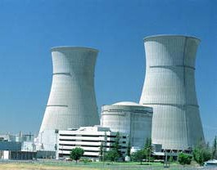-cing utility scale power levels. Their power output varies with wind speed

Courtesy of CWLP, Springfield, IL Photo by Terry Farmer
powered by a uranium fission process. They are
and often good wind sites are far from areas that need the most power, so wind accounts for only a small

Courtesy of DOE/NREL, Credit - Warren Gretz
expensive to build,
but less expensive to operate. They provide large amounts of power.
portion of generated power. The U.S. Department of Energy proposes that wind might supply 20% of the nations power by the year 2030.

Simulation Generators and their outputs
More Resources
  - Wind, 200 MW, varies with wind speed
  - Natural gas 0 MW - 500 MW, adjustable
- How Power Grids Work http://www.howstuffworks.com/power.htm
- The Power of the Wind http://www.mste.uiuc.edu/projects/wind
- The Magic School Bus and the Electric Field Trip by Joanna Cole. Illustrated by Bruce Degen. Scholastic Press, New York. 1997.
  - Coal, 300 MW - 700 MW, adjustable
  - Hydroelectric, 500 MW - 1000MW, adjustable
  - 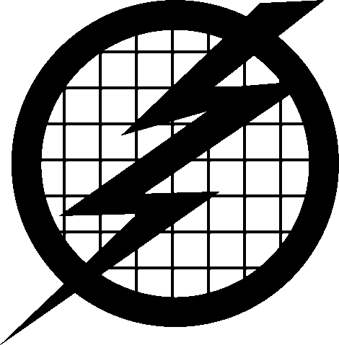Nuclear, 900 MW, not adjustable

1

The Power Grid
Lesson 1

Use the applet at http://tcipg.mste.illinois.edu/applet/pg to explore how power is distributed from generators to the communities. In the applet there are five different types of generators delivering electricity to three communities.
1. When the applet opens, are the generators making more or less power than the communities are using?
Some of the generators are able to vary their production.
Click on the up and down arrows to the right of MW output labels to change the
2. Find the five generators available in the applet. List the types and their outputs here. If a generator is able to vary its output, give its range.

- d.
e.

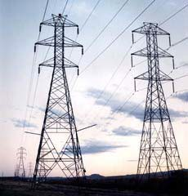Read about the power grid here.
Courtesy of DOE/NREL, Credit - Warren Gretz
The power grid refers to the system of
producers and consumers of electricity. It

includes power generators, the users of electricity, switches that control the electricity, and the system of substations, power lines, and transformers that deliver the electricity.
The arrows show the direction of the power flow and indicate the amount. Open or close the blue switches by clicking with the mouse. Explore the system by changing the power outputs and opening or closing the switches.
A community might have a generator to provide its power. The generator may be able to vary its production as the usage of the customers changes, but there may be times when the demand for energy is too great for the generator. Then the community buys electricity from another source. At other times the generator may be making more electricity than the community is
When the applet opens (or is reset), power is being produced by four of the five generators.
- Find the total amount of power being produced.
You can see the power moving from the generators through the substations and to the users in Commerceton, Industryville, and Residenceburg.
- Find the total amount of power being used by these communities.
Any power that is not used by the communities in the system is sent to other users in other systems.
- How much power is being sent to external systems?
One estimate of home energy use states 3.3 MW are needed for 1000 homes
using, so it wants to sell it.

2

The Power Grid

Comments for Teachers

Lesson 2

When the applet at http://tcipg.mste.illinois.edu/applet/pg opens, power is being produced by four of the five generators. You can see the power moving from the generators through the substations and to the users in Commerceton, Industryville, and Residenceburg. Any power that is not
used by the communities in the system is sent to users in other systems. If the generators in this system are not producing enough power, power will be purchased from other systems. In the applet this is indicated by the two External Systems. This simulation is designed to blackout if both External Systems are disconnected from the system.
The sum of the power entering a substation must equal the sum of the power exiting that substation. For example, when the applet starts (or is reset), the coal generator is sending 600 MW of power to Substation 3. Industryville is receiving 100 MW of that power and 500 MW is going to Substation 2.
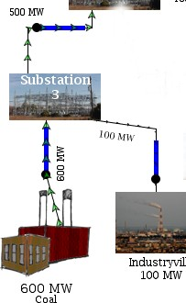Ideally, a local power system would generate exactly as much power as it uses, but because power demand is constantly changing, this is often not possible. There is no easy or economical way to store large amounts of electricity, so any “extra” power is sent to other users. Generation systems, like the one in the applet, are interconnected to allow electricity to travel. This interconnected system is the power grid.
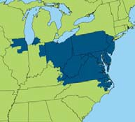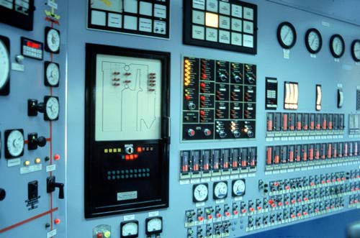There are more than one hundred energy control centers across North America. Here power system operators monitor power production, transmission and use. They try to make sure that power demand across the grid is equal to power generated. They also try to keep costs low and make sure equipment is operating safely. They may ask a generator to produce more power or less at times. When you are interacting with the applet, you are acting like a power system operator.
More Resources

McNeil Generating station control room Courtesy of DOE/NREL
- The Midwest Independent Transmission System Operator, Inc. in Indiana works to manage transmission for an area from Ohio to Manitoba http://www.midwestiso.org/home
  - PJM Interconnection is a regional transmission organization (RTO). It manages wholesale electricity in these blue shaded area. www.pjm.com.
  - Take a virtual power plant tour at Xcel Energy’s Energy Classroom

3

The Power Grid
Lesson 2

When the applet at http://tcipg.mste.illinois.edu/applet/pg opens (or is reset), power is being pro- duced by four of the five generators.
Watch the arrows and the numbers alongside the transmission lines to see changes in the system.
- Close the switch to put the nuclear plant online. What changes?

- How much power is being sent to external systems?
- What happens if the switch to one of the external systems is opened?

- How can you match the power generated to the power used?

- 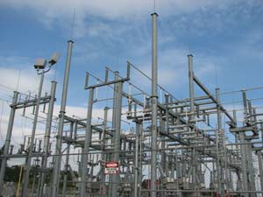Reset the system and take all of the generators offline. What happens?
A power substation
You see some parts of the power grid all around you.
There is probably a
power pole with a transformer drum very near where you live. If your neighborhood has underground power, the transformer is in a green box that is about one meter on each side. There is a power substation like the one in the photo nearby too.
Substations can split the power distribution into two or more directions, but they do not make or use power. So the power entering a substation is equal to the power leaving the substation. Another job of the substation is to take the high voltage power produced by the generators and transform it to a lower voltage that can be used in homes, schools and businesses.

- Put only the hydroelectric plant back online. Now what happens?

Reset the system, then answer these questions.
- Adjust the coal power plant to be on line at maximum power. How much electricity is flowing into substation 3?

- How much electricity is flowing out of substation 3?
Where is it going?

- What changes when you open the switch on the line leaving the coal plant?

4

The Power Grid

Comments for Teachers

Lesson 3

The transmission lines in the applet at http://tcipg.mste.illinois.edu/ applet/pg have varying capacities. They range from 1000 MW to 2000 MW. The line flow for each line is noted near the line and changes as the power flow changes.
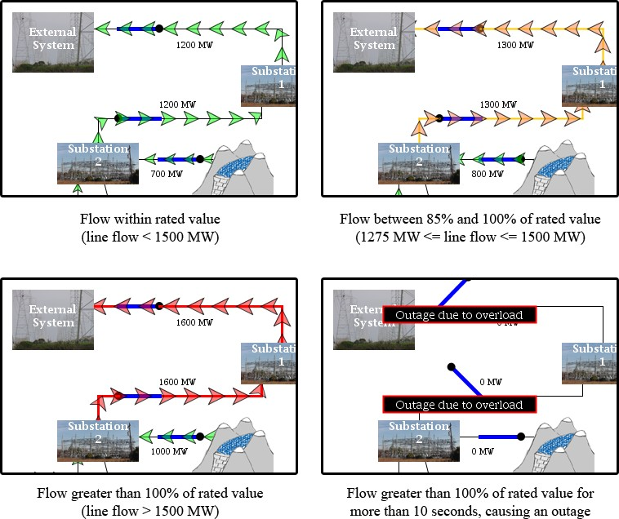
When a line is carrying less than 85% of its capacity, the arrows are green, indicating that the flows are within normal operating conditions. As the flow moves past 85% of the line capacity, the arrows turn orange, indicating that the lines should not be made to carry much more power. As the flow continues to increase past the maximum, the arrows turn red. If the arrows remain red (i.e., the line remains overloaded) for approximately 10 seconds, the line automatically opens and a notification is displayed
If a community demands more power than the transmission line that serves it can
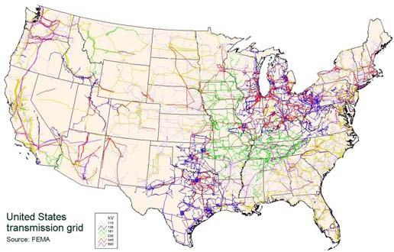carry, the community will blackout. A community may also blackout if a line is damaged. In the applet as well as in reality, a transmission line
problem in one area of the system can cause blackouts in several areas.
Power lines are designed with maximum capacities. The large diameter, more expensive high voltage lines leaving a generating plant are designed to carry the maximum that the plant can produce. It is often difficult to design a transmission line that supplies a community because growth and demand are harder
to estimate.
More Resources
- Electric Power Generation, Transmission and Distribution: Illustrated Glossary (OSHA) http:// www.osha.gov/SLTC/etools/electric_power/illustrated_glossary/index.html
- Public Service Commission of Wisconsin’s Electric Transmission Lines http://psc.wi.gov/thelibrary/ publications/electric/electric09.pdf
- CBS News coverage of the power blackout in August, 2003 http://www.cbsnews.com/ stories/2003/08/14/national/main568370.shtml
- Energy Story, California Energy Commission http://www.energyquest.ca.gov/story/

5

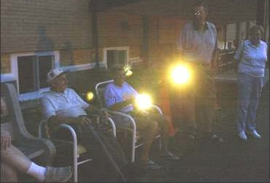The Power Grid Lesson 3

Victoria Towers residents sit outside with their flashlights during the power blackout Aug. 14, 2003, in Meriden, Connecticut (Photo AP)
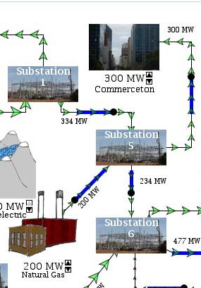
When the applet at http://tcipg.mste.illinois.edu/applet/pg opens (or is reset), all of the power flow arrows are green. The transmission lines have varying capacities. Just
as in an actual power system, if a line is asked to carry too much power the line will be opened creating a power outage. To make it easy for the system operator (that’s you!) to see when lines are in danger of becoming overloaded, the arrows in the applet change color.
- Reset the system and notice the line leading from Substation 5 to Commerceton. How much power is this line carrying? Click on the up arrow to increase Commerceton’s power demand. What happens to the arrows on the line?
- At what load do the arrows change to orange? What
color are the arrows when the demand is 1000 MW? What happens when the load on the line is increased again?
How can you fix it?

Explore the applet to find the line maximum capacities for all the lines.
Power leaving the generating plant is carried by high voltage, long distance transmission lines to a
distribution substation. These lines look like the photo. The power leaves the substation on the lines you see strung from power poles. The transmission lines that have the largest diameters are designed to carry the most power. Transmission lines become hot and expand if they carry more power than they are designed to carry. This can cause the line to sag and touch the ground or some other object.
When this happens the line is opened and a power outage will occur.
Reset the system, put the nuclear power plant online and then increase the power demanded by Residenceburg to 1850 MW.
- What’s causing a problem?

- Reduce the potentially dangerous line overload without taking the nuclear plant offline. How do you do this?

- It’s a hot summer day and power demand in Residenceburg is 1600 MW. Commerceton is demanding 850 MW and Industryville needs 800 MW. You put all of your generators online at maximum capacity. Are all of your lines operating safely?
- Are you able to produce enough power to meet the demand or do you need to get power from the external system?

6

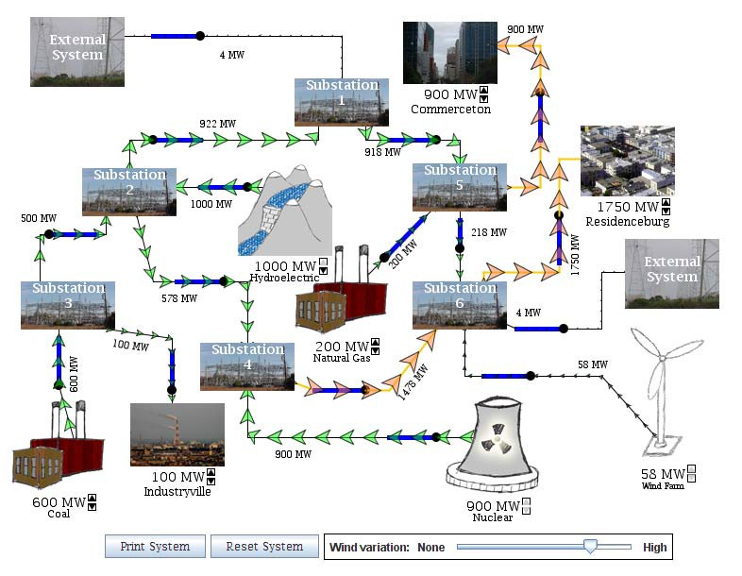The Power Grid

Lesson 4

Comments for Teachers
This configuration of the applet at tcipg.mste.illinois.edu/applet/pg shows Residenceburg and Commerceton demanding power that is near the maximum transmission capacity of the power lines that supply their
communities. The generators in the system are able to provide the demanded power with very little demand on the external systems, but if either or both of these communities demand much more power the transmission line supplying it may open and blackout the community. The high demand from these communities also puts a high load on lines elsewhere in the system. This is an example of how a problem in one part of the power grid can become a massive outage.
Discuss with students the benefits of combining local generation with the external system to allow for changing demands from users. While the interconnected grid allows

for more efficient use of generated power, there is always the danger of a problem in one part of the grid affecting large areas of the system. Power engineers and others are working to find ways to maximize the reliability of the power grid.
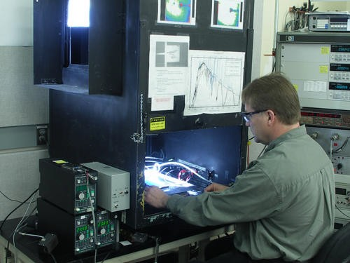The grid of today has its beginnings in the late 1800’s and has continued to expand and improve. There are more than 9,000 generators delivering more than 1 million megawatts of electricity over more than 300,000 miles of transmission lines. As people use more electricity, for computers and other technologies, the electric grid needs to become more efficient. The Smart Grid represents the effort to use digital communication technologies to modernize

Courtesy of DOE/NREL, Credit -
Linenberger, Mike
the grid. These technologies make the electricity system more efficient and reliable. It will be more capable of:
- effectively integrating renewable energy sources
- maximizing current generation
- offering consumers opportunities to manage their energy use
and costs.
More Resources

- The Federal Energy Regulatory Commission is responsible for the reliability of high voltage transmission between states. http://www.ferc.gov/about/ferc-does.asp
- The U.S. Energy Information Administration’s Energy Kids provides information bout the energy sources used to make electricity. http://www.eia.gov/kids/energy.cfm?page=electricity_home-basics
- What is the Smart Grid? http://www.smartgrid.gov/the_smart_grid
- Energyville is an energy game sponsored by Chevron Corporation. http://www.energyville.com/energyville/

7

The Power Grid Lesson 4
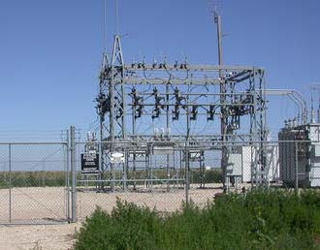When the applet at http://tcipg.mste.illinois.edu/applet/pg opens (or is reset), the generators are producing more power than the communities are using, and power is being sent to the external system. Power system operators try to match power generation to demand, because this is usually least expensive. When communities need more power, the generators are adjusted. The transmission line flows need to be kept at safe levels too.
Courtesy of DOE/NREL, Credit - Kelly, Marguerite
Reset the system and then set the power demand for Residenceburg at 1500 MW, for Industryville at 600 MW and for Commerceton at 800 MW. Turn the nuclear power plant on to meet this increased demand.
- Bad weather can sometimes cause breaks in transmission lines. What happens to the system when you open the line between substations 4 and 6?

Reset the system, turn on the nuclear power plant and then open the line between substations 1 and 2.
- What happens?

- What is the problem?
- Fix it by changing one switch. What did you do?

- Reset the system and then set both the coal generator and Industryville to 600 MW. What is happening between substations 2 and 3?
There are six major Regional Transmission Organizations (RTO’s) or Independent System Operators (ISO’s) in the United States. These voluntary, independent organizations monitor electricity generation and demand and communicate with power plants and utilities to balance supply and demand. The Federal Energy Regulatory Commission (FERC) encourages the formation of these nonprofit organizations because they promote efficiency in wholesale electricity markets.

- Open the line between substations 2 and 3. Now what is happening?

- What happens to the other communities?

- Which line in this system do you think is most likely to overload?

8

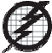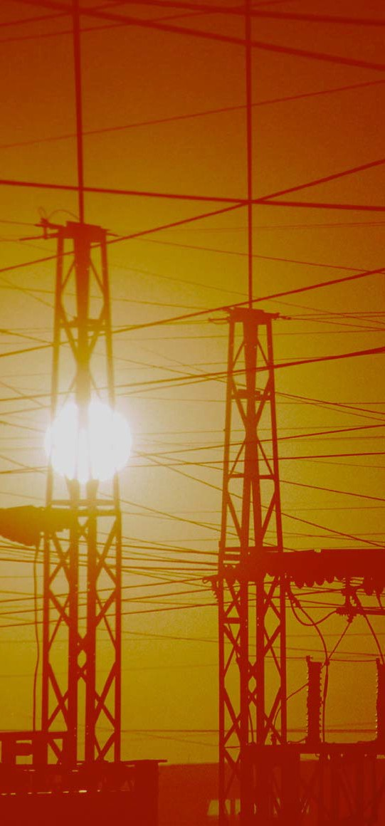

TCIP is funded by:

The National Science Foundation The Department of Energy
The Department of Homeland Security

For More Information:

Information Trust Institute University of Illinois at Urbana-Champaign
450 Coordinated Science Laboratory 1308 West Main Street, MC-228 Urbana, IL 61801

217.333.3546

info@iti.illinois.edu http://www.iti.illinois.edu
TCIP Educational Development is a joint project of the Office for Mathematics, Science and Technology and Information Trust Institute at the University of Illinois.
These materials were developed by Jana Sebestik and Zeb Tate in consultation with George Reese and Molly Tracy http://tcipg.mste.illinois.edu/

